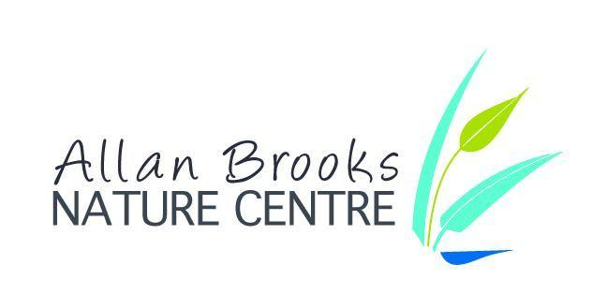 Date:Click or tap to enter a date.

Volunteer Information/Application Form

Name: Click or tap here to enter text.

Address: Click or tap here to enter text.

Preferred contact number: Click or tap here to enter text. Cell ☐ Home ☐

Email Address: Click or tap here to enter text.

Emergency Contact Name: Click or tap here to enter text. Emergency Contact Telephone: Click or tap here to enter text.

Availability: Please indicate what days and times are most convenient for you.

☐ Weekday mornings ☐ Weekday afternoons ☐ Weekends ☐ Events

How many hours a week/month are you available to volunteer with us? Click or tap here to enter text.

Please note that ABNC is open from mid April through October. There may be some off-season opportunities.

Please Check Your Area(s) of Interest:

☐ Buildings and Grounds: general upkeep and repairs, work bees, gardening, guardian of the grasslands

☐ Education: school program lead, nature interpreter, summer camp assistant

☐ Events: on-site and off-site, fundraisers (plant and garage sales, gala)

☐ Office Support: data entry and management, storing, organizing, filing

☐ Photography: capture activities, events, flora and fauna, etc.

☐ Visitor Services: welcome and interact with visitors, provide Centre tours, manage gift shop

What experience /skills do you have in your area(s) of interest? Click or tap here to enter text.

What motivated you to complete an application to volunteer with us? Click or tap here to enter text.

How did you hear about volunteering with us? Click or tap here to enter text.

Please provide two references:

Name: Click or tap here to enter text.

Phone #: Click or tap here to enter text.

Relationship: Click or tap here to enter text.
Name: Click or tap here to enter text.

Phone #: Click or tap here to enter text.

Relationship: Click or tap here to enter text.

Consent to photographing: Do you give ABNC staff permission to photograph you for the purpose of the Centre’s newsletter, website, social media and promotions? YES ☐ NO ☐

Please read carefully before signing:

I understand and agree that volunteering with Allan Brooks Nature Centre is conditioned upon:
- Completing a current Criminal Records Check (Allan Brooks Nature Centre will pay and will help facilitate the criminal records check.)
- Supporting ABNC’s Mission and Core Values “To promote the enjoyment, understanding and stewardship of the North Okanagan’s unique and diverse natural environment.”
- Willingness to be trained and to follow the rules and regulations governing ABNC that are in effect at this time.
- All information I have given on this application is accurate and verifiable.

Signature: Date: Click or tap here to enter text.

Allan Brooks Nature Centre (ABNC) is committed to protecting the privacy of personal information in our possession or under our control. The personal information collected on this form will be used to identify appropriate volunteer roles. This information will be stored in a locked cabinet and if you become a volunteer it will be entered into our secure database to track your volunteer activities. ABNC values the trust of our volunteers and staff and we recognize that maintaining this trust requires transparency and accountability in handling personal information.

Please drop off, mail or email your completed form to:

Allan Brooks Nature Centre
250 Allan Brooks Way, Vernon, BC V1T 9L4
PO Box 20038
Email: volunteer@abnc.ca Phone: 250-260-4227

